

Ben-Gurion University of the Negev

Faculty of Engineering Science

School of Electrical and Computer Engineering

Dept. of Electrical Engineering

Finals Year Engineering Project

PDR

Unmanned Surface Vehicle for Searching and Survey of shallow water bodies

|  |  |
| --- | --- |
| **p-2023-115** | **Project ID** |
| **Yuval Avigdor – 203387097**  **avigdory@post.bgu.ac.il**  **Yonatan Axelrad – 311366249**  **axelray@post.bgu.ac.il** | **Students** |
| **Hugo Guterman** | **Supervisor** |
| - | **Sponsors** |
| **25.11.2022** | **Submission date** |

**Unmanned Surface Vehicle for Searching and Survey of shallow water bodies**

Authors: Yuval Avigdor (avigdory@post.bgu.ac.il), Yonatan Axelrad ([axelray@post.bgu.ac.il](mailto:axelray@post.bgu.ac.il))

Adviser's name: Prof Guterman Hugo.

**Key words**: Side scan sonar, ASV, AUV, Seabed, Real-time communication.

**Abstract:**

Of all the different types of water reservoirs, this project will focus mainly on shallow water bodies (*e.g. small lakes, fish pools, drinking water reservoirs etc.).* It is important to keep in mind the fact that many of these bodies of water are known to have interference factors like water pumps and muddy waters.

Over the last decade, more and more people are realizing the need in surveying the seabed of these bodies of waters, both for ecological research and also police matters such as recovering human bodies thrown in.

The project aims to implement a design that can be rapidly deployed in the field and that can navigate its way in shallow water reservoirs. Using different sensors, the system will give the users a better understanding of what the area underwater looks like and even where certain objects are.

Solutions offered today mostly make use of AUV (Autonomous Underwater Vehicles) that mainly send information to the user at the end of the run, due to limited bandwidths of acoustic modems.

The solution proposed in this project is instead an autonomous Kayak-based ASV (Above Surface Vehicle) that uses real-time communication to transmit data from sensors such as a side scan sonar, camera and GPS to an operator in a remote location. The platform will be implemented with a guidance system that would allow it to receive a pre-determined route and move by it.

Having real-time data will ensure that the platform doesn't waste time and power. With a real-time image, the operator could decide to end a mission if he sees the desired object, rather than waiting for the run to end and seeing what data the vehicle gathered. Moreover, an autonomous operation will cut expenses by reducing the need of human work force.

**תקציר**

**Project goals:**

The primary goal of the project is to implement the autonomous guidance system that will allow the ASV to keep its route, as well as implementing monitor modules for all sensors used on the platform (*e.g. Side scan sonar, Camera, Magnetometer, GPS etc.)*. The modules will have to communicate in rea-time and transmit data to the operator.

The main goal can be broken down into:

* Establishing full communication with all sensors and receiving a clear picture from the sonar.
* Implementing control modules for motors.
* Working with a mechanical engineering team to figure out the optimal positioning of both the motors and the sonar.
* Developing software (coding will be done in Python) that would integrate all modules and communicate between them. The communication between modules will be ROS2 based.

**Measure of success:**

The project will be considered successful under the following conditions:

1. A clear image can be transmitted by the sonar and received by a remote computer.
2. The platform can navigate itself by receiving target waypoints and a final run time.

At roughly 300 meters the expectation is that high-bandwidth data will be received, and at around 2 Kilometers, low-bandwidth data will be received.

**Specifications:**

The platform in this project is an autonomous Kayak-based ASV that does real-time seabed mapping. Movement of the ASV will be controlled by an implemented guidance algorithm that makes use of target waypoints and local positioning received via onboard GPS.

The main chamber will house the electronics involved in the project and will be mounted atop the Kayak. An UP ™ board computer will make use of the ROS2 system in order to handle communication between the sensors as well as controlling the motors.

Two cameras will be mounted on the platform – below and above water in order to give the user additional angles.

The Sonar which is placed in a sealed chamber will be mounted below the Kayak (pending sit down with mechanical team) and will have environmental sensors to monitor the status of the sealed chamber.

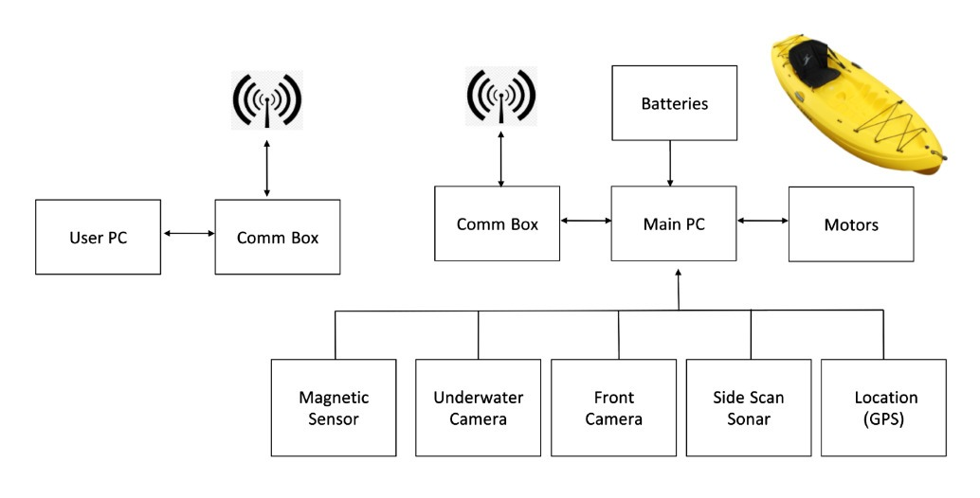

Figure 1 System schematic layout

* Batteries: the system will include two cells of lithium battery.
  + Voltage: 28.8V nominal.
  + Capacity: 49.5Ah.
  + Pack Power: 1425Wh.
* Motors: Two Torqeedo Ultralight 403A Pylon motors
  + Max. input power 400W
  + Max. propulsive power 180W
  + Total weight 8.8kg.
* Computer: UP Board series
  + Intel® ATOM™ x5-Z8350 Processors 64 bits up to 1.92GHz.
  + 4GB DDR3L RAM
  + 64GB eMMC.
  + 4x USB2.0 on connectors.
  + UART on header.
  + I2C on header.
* Cameras - Flea3-GE:
  + Front Camera: In order to define border limits (coastline).
  + Underwater Camera: Scan the area below the kayak to find to detect objects.
  + 1.3MP image.
  + 31FPS at 1288x694.
* Location: GPS sensor (NEO-M8N) for real time position and navigation system.
  + Update rate up to 10 Hz.
* Side Scan Sonar:  Klein UUV-3500, survey the underwater surface, (see figure 2).
  + Operation frequencies - 455 kHz, 900 kHz.
  + Beam width - horizontal: 0.34°, vertical: 45°.
  + Typical range - 150 m @ 455 kHz, 75 m @ 900 kHz.
  + Multibeam Bathymetry – 125 m nominal/side (typically 10 to 12 times altitude) @ 455 kHz.

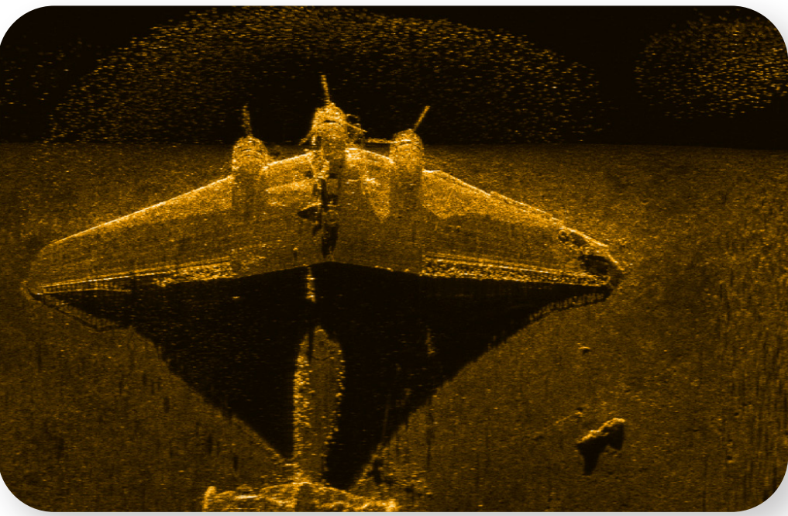

Figure 2 Taken by Side Scan Sonar (Klein uuv 3500)

* Communication Box - RF modems for transmitting data and telemetries between the kayak and the operator on shore:
  + WIFI - bit rate up to 150Mbps @ 2.4GHz.
  + Lora SX1276 - bit rate up to 1.4kbps @ 433MHz.
* Magnetic Sensor: Measure magnetic field beneath the kayak.
  + Operating range: 20000 to 100000 nT
  + Max sample rate: 20Hz

**Design proposal:**

The system has three main parts:

* Main chamber, which contains sensors and communications.
* Side-scan sonar chamber.
* Motors.

**Main chamber**: The main chamber will mounted on the platform, connected to a 28v battery. The chamber will be IP67 proof electricity box with the following design:

Figure Main chamber design

**The side-scan sonar chamber:** The side scan sonar transducers are located beneath the ASV as they must be below sea level to operate correctly. For maximum heat dissipation, and due to cable length limitations, the Sonar chamber will also be mounted below the ASV. The chamber is fully waterproof (up to depths of 300 meters) and all connectors and cables attached to it are also waterproof. The chamber is given an environmental sensor to monitor the pressure, humidity and temperature of the chamber to monitor the sealing level of the chamber.

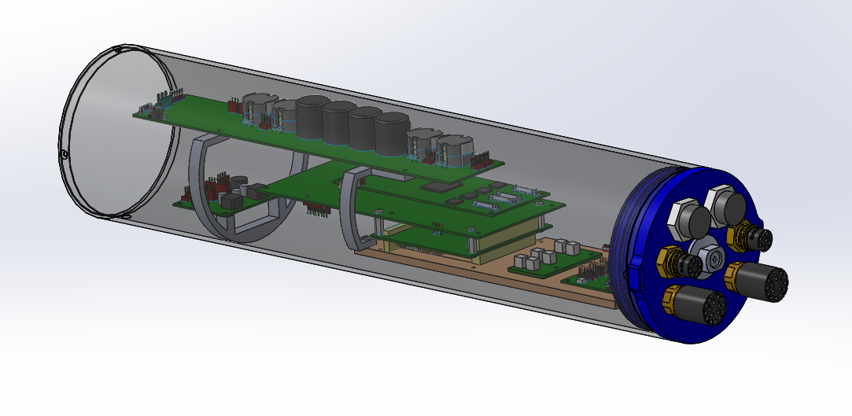

Figure Side-scan Sonar chamber design

**Motors:** The motors used by the platform are Torqeedo Ultralight 403A Pylon motors. These motors are equipped with position sernsors that make sure that if the orientation of the motors is not in the right direction, they'll stop all operations. Means of communication with the motors is by Ethernet (RS485 to USB).

**Project constraints:**

**Project assumptions:**

**Project testing proposal:**

**Schedule and work plan:**

**Budget evaluation:**

**Reference:**

**המלצת ציון (ע"י מנחה אקדמי) לדו"ח מכין**

אם יש צורך, לכל סטודנט/ית בנפרד

מספר הפרויקט: _____-____20-P

שם הפרויקט:

שם המנחה החיצוני:

שם המנחה מהמחלקה:

שם הסטודנט/ית: ת.ז.:

|  |  |  |  |  |  |  |  |
| --- | --- | --- | --- | --- | --- | --- | --- |
| % |  | חלש  55-64 | בינוני  65-74 | טוב  75-84 | ט"מ  85-94 | מצוין  95-100 |  |
| 15 | הבנת הנושא הצורך וסביבת היישום |  |  |  |  |  |  |
| 15 | חיפוש מקורות והבנת עבודות דומות |  |  |  |  |  |  |
| 15 | שלמות דף מפרט (הצעת מחקר) |  |  |  |  |  |  |
| 15 | הצעת תכנון ותכנון הבדיקות הסופיות |  |  |  |  |  |  |
| 10 | גילוי יוזמה וחריצות |  |  |  |  |  |  |
| 20 | פתרון בעיות, מקוריות ותרומה אישית  (מעבר למילוי ההנחיות) |  |  |  |  |  |  |
| 10 | הערכת תקציב, לו"ז וחלוקת עבודה,  ציון מקורות ושלמות כללית |  |  |  |  |  |  |

הערכת רמת הקושי של הפרויקט: קל מאוד / קל / בינוני / קשה / קשה מאוד

הערות: